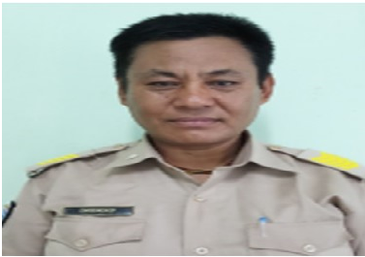

Name : Dhendup
Position Title : S1A
Agency : Regional Revenue & Customs Office, Phuntsholing
Active Service : 14/01/1986 to 01/02/2021
Mr. Dhendup (EID No. 8601074), Customs Inspector I, Regional Revenue & Customs Office, Phuntsholing under Department of Revenue and Customs Office has retired from the Civil Service with effect from 1st February 2021.
The Ministry of Finance would like to convey our sincere gratitude to him for rendering 35 years and 15 days of service with utmost dedication and sincerity to the Tsa-Wa-Sum.

