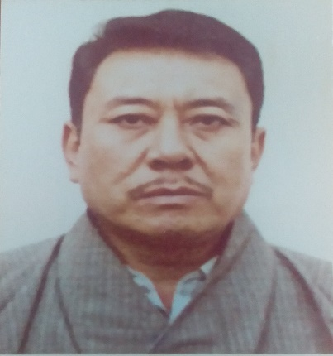

Name : Karma Tenzin Dardor
Position Title : P2 A
Agency : Regional Revenue & Customs Office, Gelephu
Active Service : 07/05/1984 to 01/11/2020
Mr. Karma Tenzin Dardor (EID No. 8405036), Joint Collector, Regional Revenue & Customs Office, Gelephu under Department of Revenue and Customs Office has retired from the Civil Service with effect from 1st November 2020.
The Ministry of Finance would like to convey our sincere gratitude to him for rendering 36 years, 5 months and 7 days of service with utmost dedication and sincerity to the Tsa-Wa-Sum.

